FULL ADDER

**PROGRAM:**

full_adder( A, B, Cin, S, Cout);

input wire A, B, Cin;

output reg S, Cout;

always @(A or B or Cin)

begin

S = A ^ B ^ Cin;

Cout = A&B | (A^B) & Cin;

end

endmodule

**WAVE FORMS:**

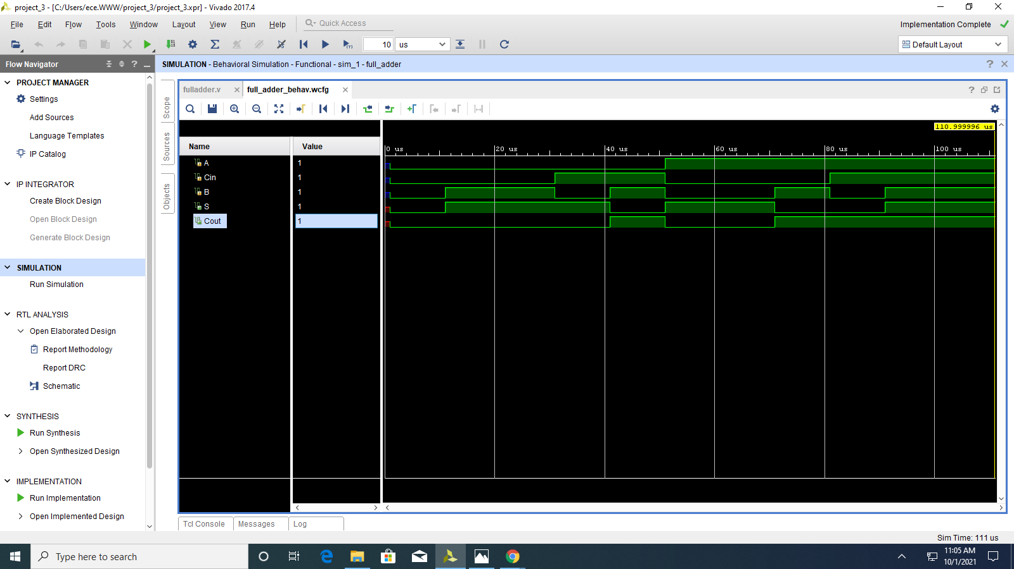

**RTL SIMULATION:**

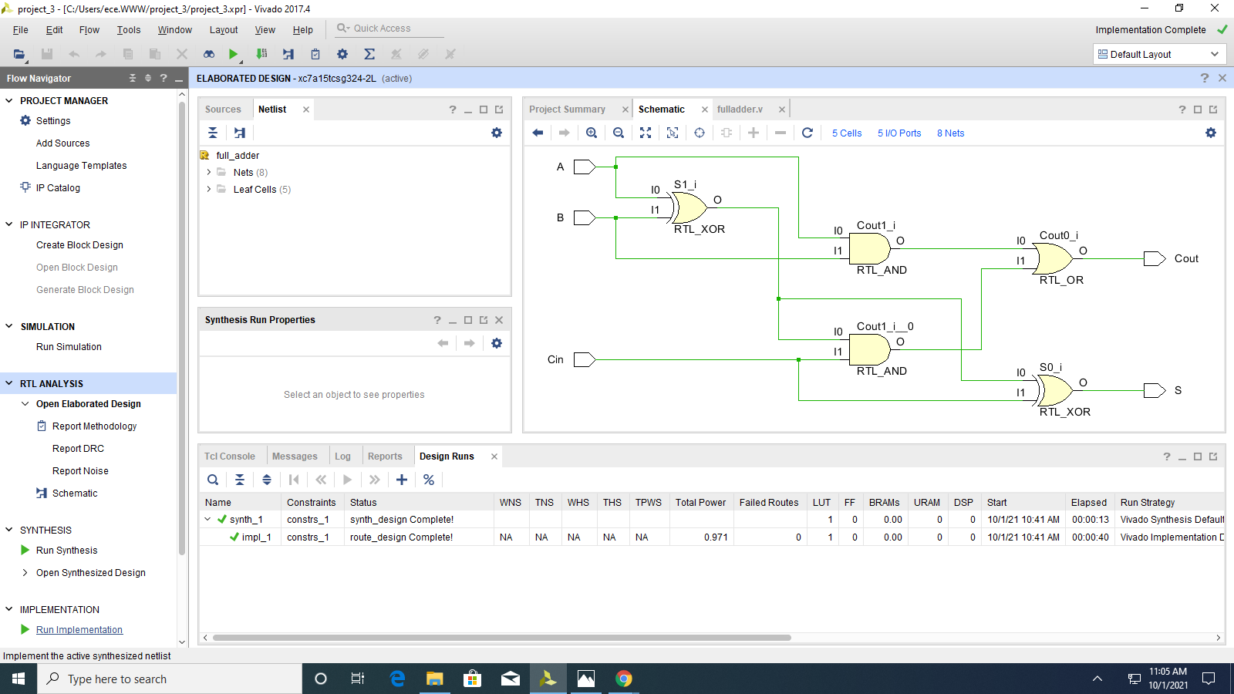

**#5**